

**Technical Report On**

**CREATIVE-PORTFOLIO WEBSITE**

By

Shivansh Srivastava (1903420100102)

Submitted to the department of Computer Science and Engineering in partial fulfilment of the requirements for the degree of

**Bachelor of Technology**

**In**

**(Computer Science Engineering)**



**Department of Computer Science & Engineering**

**United College of Engineering and Research,Prayagraj,UP**

**Dr. A.P.J. Abdul Kalam Technical University**

**December 2022**

**TABLE OF CONTENT**

|  |  |  |
| --- | --- | --- |
| **SR.No** | **INDEX** | **Pg.No** |
| 1) | DECLERATION | 1 |
| 2) | CERTIFICATE | 2 |
| 3) | ACKNOWLEDGEMENT | 3 |
| 4) | OBJECTIVE | 4 |
| 5) | LIST OF FIGURES   1. INTODUCTION 2. HTML 3. FEATURES OF HTML 4. CSS 5. FEATURES OF CSS 6. JAVASCRIPT 7. FEATURES OF JAVASCRIPT | 5-9 |
| 6) | BREIF DESCRIPTION   1. HOME SECTION 2. ABOUT SECTION 3. SKILLS SECTION 4. WORK SECTION 5. VISIT PROFILE SECTION 6. ACHIEVEMENT SECTION 7. PROJECT SECTION 8. CONTACT SECTION 9. FOOTER SECTION | 10-15 |
| 7) | DEPLOYMENT AND HOSTING | 16 |
| 8) | CONCLUSION | 17 |
| 9) | REFERENCES | 18 |

**DECLARATION**

I hereby declare that this submission is my own work and that, to the best of my knowledge and belief, it contains no material previously published or written by another person nor material which to a substantial extent has been accepted for the award of any other degree or diploma of the university or other institute of higher learning, except where due acknowledgment has been made in the text.

**Signature**

**Name -**Shivansh Srivastava

**Roll No –** 1903420100102

**Date -** 23/12/2022

**CERTIFICATE**

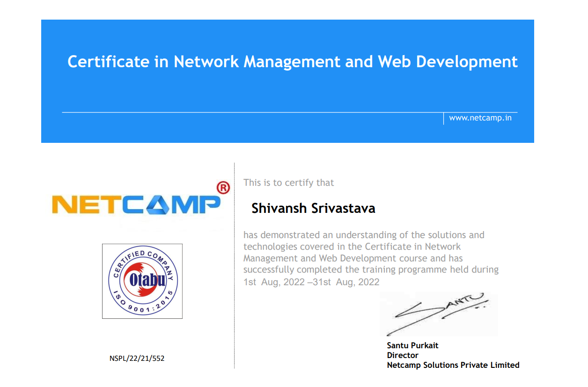

**ACKNOWLEDGEMENT**

It gives me great pleasure to present the report of the B.Tech Mini Project undertaken during B.Tech Fourth Year. I owe special debt of gratitude to Sir Santu Purkait, Director Netcamp Solutions Private Limited for his constant support and guidance throughout the course of our work. His sincerity, thoroughness and perseverance have been a constant source of inspiration for me. It is only his cognizant efforts that our endeavours have seen light of the day.

I also do not like to miss the opportunity to acknowledge the contribution of seniors for their kind assistance ,support and co-operation during the development of my project.

**Signature**

**Name -**Shivansh Srivastava

**Roll No -**1903420100102

**Date -**23/12/2022

**OBJECTIVE**

As we know that every software has a goal for which it is developed and so it is here too.

My wish is to develop a Portfolio website that will save the time of the people and recruiters connecting with me professionally through Creative Portfolio dashboard that will display the professional and academic background of my through brief description about my skills, work experiences, internships, projects along with social media links and contact details in respective sections.

**LIST OF FIGURES**

1. **INTODUCTION**
2. **HTML**
3. **FEATURES**
4. **CSS**
5. **FEATURES OF CSS**
6. **JAVASCRIPT**
7. **FEATURES OF JAVASCRIPT**

**INTRODUCTION**

A portfolio website is a unique way to showcase your work and let others know about yourself. It's like an evergreen platform for your projects, case studies, and information about you. In addition, it's one of the best ways to express your personality, experience, and capabilities.

In a nutshell, you need a portfolio website to showcase your work. Whether you’re an individual, a small team of two or a company of ten people, it’s crucial that you have a unique online approach. A website portfolio will help you stand out from the crowd, show your uniqueness, build trust, and make sure that others actually find you.

And this Project on Creative portfolio website is brief description about an individual. This project comprises of three section HTML for creating mark-up of the application on the web ,CSS provides styles to each element of the website and JavaScript provides functionality to the website application.

**HTML**

#### Hyper Text Mark-up Language

HTML stands for Hyper Text Markup Language, HTML is the standard markup language for creating Web pages it describes the structure of a Web page and consists of a series of elements,HTML elements tell the browser how to display the content.

HTML, in full hypertext markup language, a formatting system for displaying material retrieved over the internet. Each retrieval unit is known as a Web page (from World Wide Web), and such pages frequently contain hypertext links that allow related pages to be retrieved. HTML describes the structure of a Web page.HTML consists of a series of elements. HTML elements tell the browser how to display the content.

**FEATURES OF HTML**

1. User Friendly and simple
2. Semantic Structure
3. SEO-Search Engine Optimization
4. Platform Independent
5. Media Support

**CSS**

#### Cascading Style Sheets

CSS is a modern, responsive, mobile first CSS framework. It provides equality for all browsers: Chrome. Firefox. Edge. IE. Safari. Opera.CSS provides equality for all devices: Desktop. Laptop. Tablet. Mobile.CSS is standard CSS only (No jQuery or JavaScript library).

CSS is the language for describing the presentation of Web pages, including colors, layout, and fonts . It allows one to adapt the presentation to different types of devices, such as large screens, small screens,or printers. CSS is independent of HTML and can be used with any XML-based markup language.

**FEATURES OF CSS**

1. **Opportunity in Web designing:** If anyone wants to begin a career in web designing professionally, it is essential to have knowledge of CSS and HTML.
2. **Website Design:** With the use of CSS, we can control various styles, such as the text color, the font style, the spacing among paragraphs, column size and layout, background color and images, design of the layout, display variations for distinct screens and device sizes, and many other effects as well. 11
3. **Web Control:** CSS has controlling power on the documents of HTML, so it is easy to learn. It is integrated with the HTML and the XHTML markup languages.
4. **Other Languages:** Once we have knowledge of some basics of CSS and HTML, other associated technologies like Angular, PHP, and JavaScript are become clearer to understand.

**JS**

#### JavaScript

JavaScript is the world's most popular programming language.It is the programming language of the Web.JavaScript is easy to learn.

It is a prototype-based, multi-paradigm scripting language that is dynamic, and supports object-oriented, imperative, and functional programming styles. JavaScript runs on the client side of the web, which can be used to design / program how the web pages behave on the occurrence of an event.

**FEATURES OF JS**

JavaScript is one of the most popular languages which includes numerous features when it comes to web development. It's amongst the top programming languages as per Github and we must know the features of JavaScript properly to understand what it is capable of.

Some of the features are lightweight, dynamic, functional and interpreted. Now we are going to discuss some important features of JavaScript.

>Light Weight Scripting language

>Dynamic Typing

>Object-oriented programming support

>Functional Style

>Platform Independent

>Prototype-based

**BREIF DESCRIPTION**

**Home Section**

It displays website name as Creative with logo and navigation bar showing various tabs such as Home, About, Skills, Achievements, Projects & experiences and know more and displays my name and work status a short introduction about me and my display picture on left divison of home section and a download cv button.

It Also consists of Contact Button which redirects to mail where visitor can contact me via mail options with a message showing ‘Mail from the website’ on top right corner with hover effect on it using css.

*(Navigation Bar With Contact Button)*



*(Home Section )*

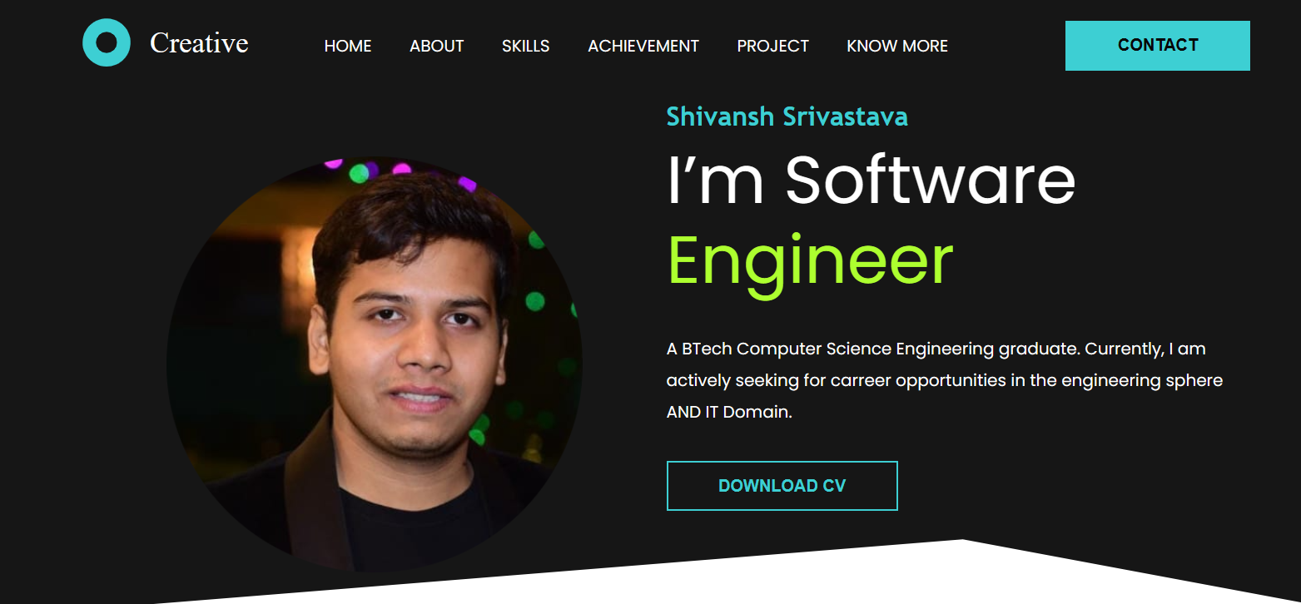

**About Section**

It displays a brief introduction about me and <span></span> tags are used here to separate the styling of font style with different colour and pattern. 2 different heading tags <h1> </h1> and <h3></h3> with a <p></p>paragraph tags are used.

Below the description in <p>tag social media handles are provided to connect on network using redirect link by <a href> anchor tags.

*(About Section )*

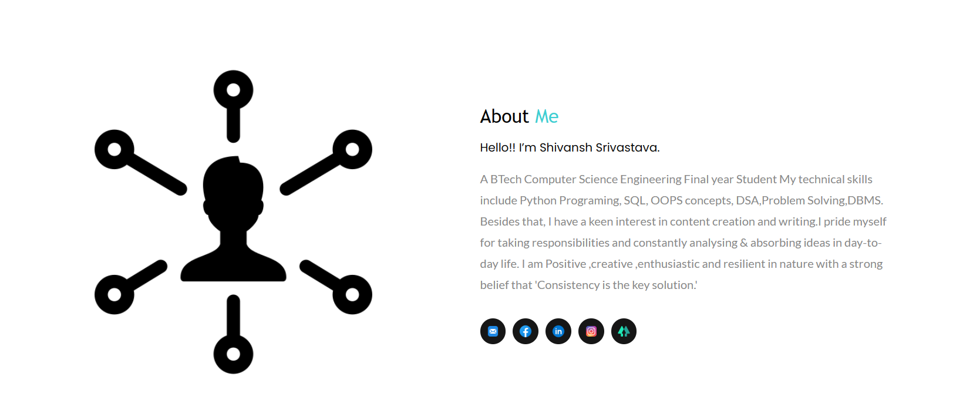

**Skills Section**

This Section of creative portfolio website displays in grid form using css grid different technical skills i have acquired as a part of the academic years and as by sliding over the domains mentioned one can view the certification I Have completed from various organisation and during summer internships and boot camps.

Some of the mentioned are like : Hackerrank Python Skill certification, Andoid development Ethical Hacking and different tags used here are <div>,<img> etc.

*(Skills Section)*

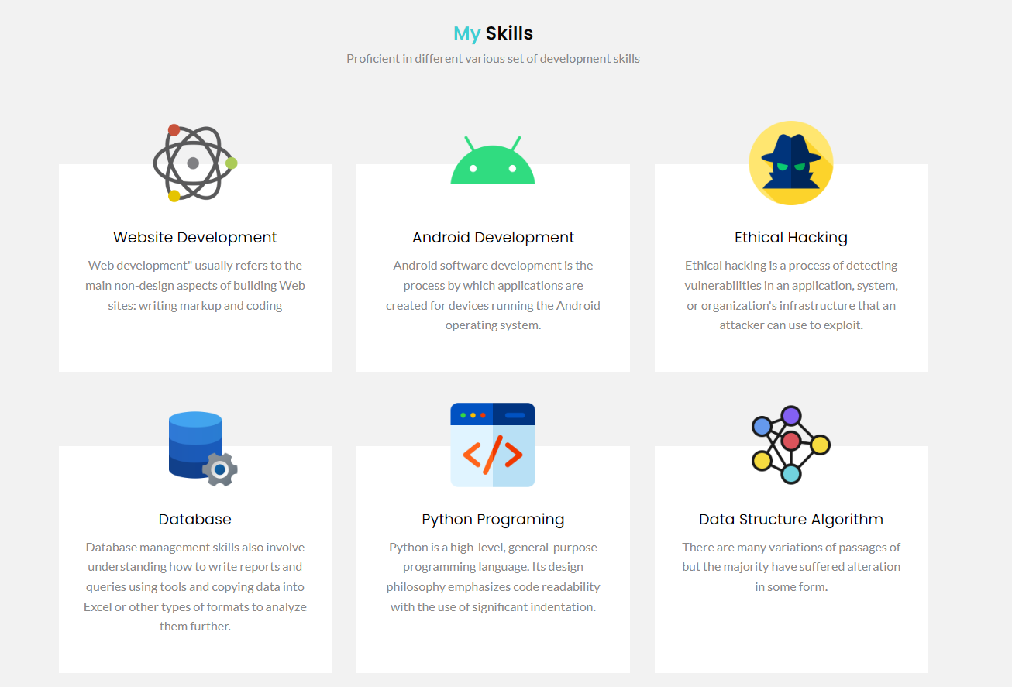

**Work Section**

This section of website defines a statement that I am open to work for Software Related Roles And one can download my Resume using Download CV Button and on hovering over the Software Developer one can redirected to My LinkedIn handle.

*(Work Section)*

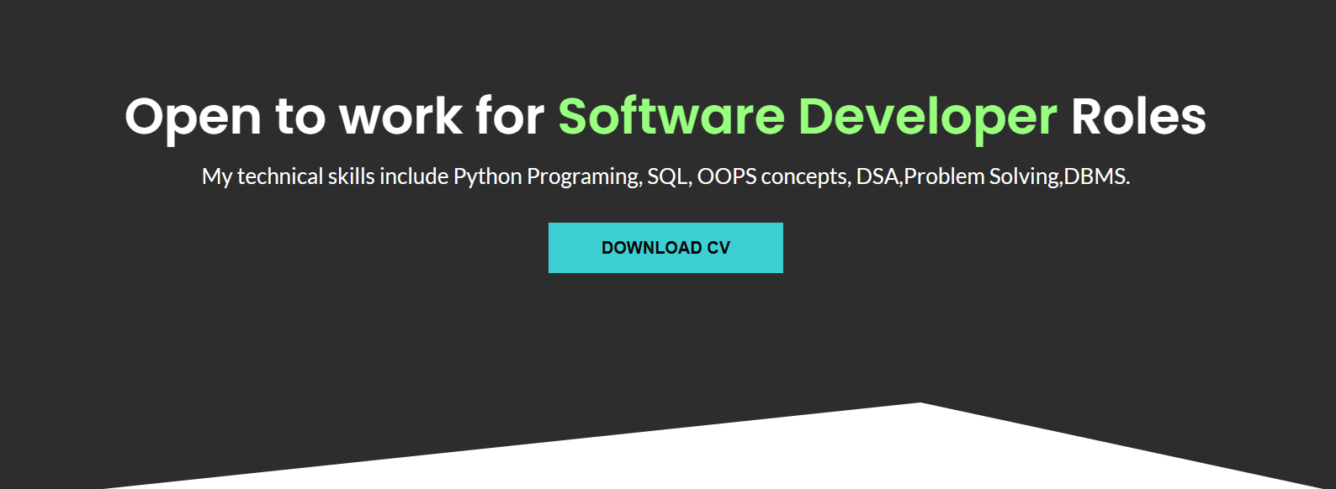

And anyone can connect with me over different coding platforms like GFG,Hackerrank,Leetcode and Professional network Of LinkedIn .

*(Profile section )*

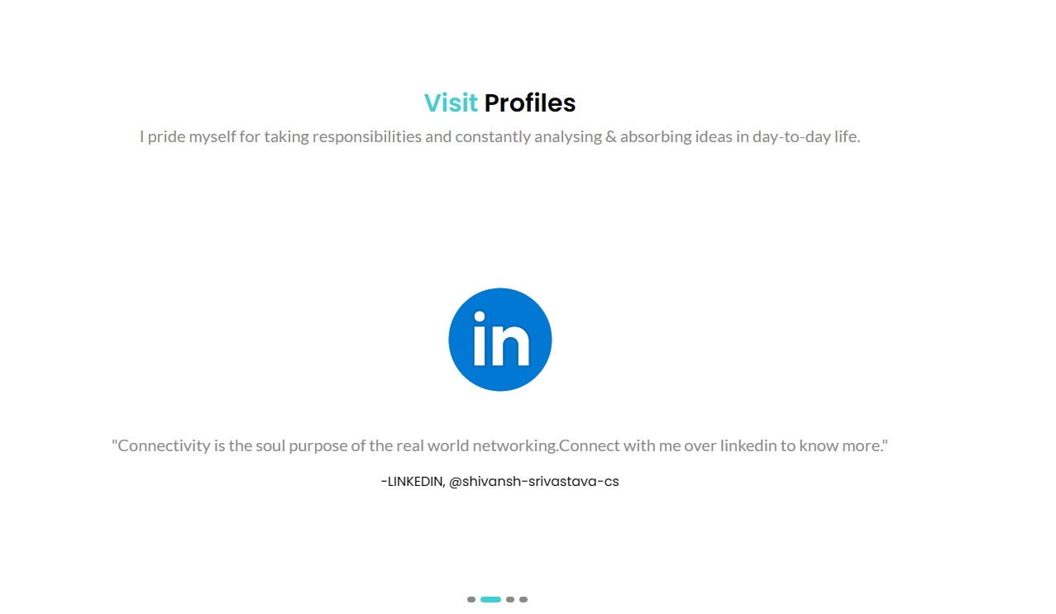

**Achivement Section**

In this I have showcase and mentioned achievements and my work experiences during various trainings and boot camps and attached are pdf of certificates and recourses from where I have earned and learned this.

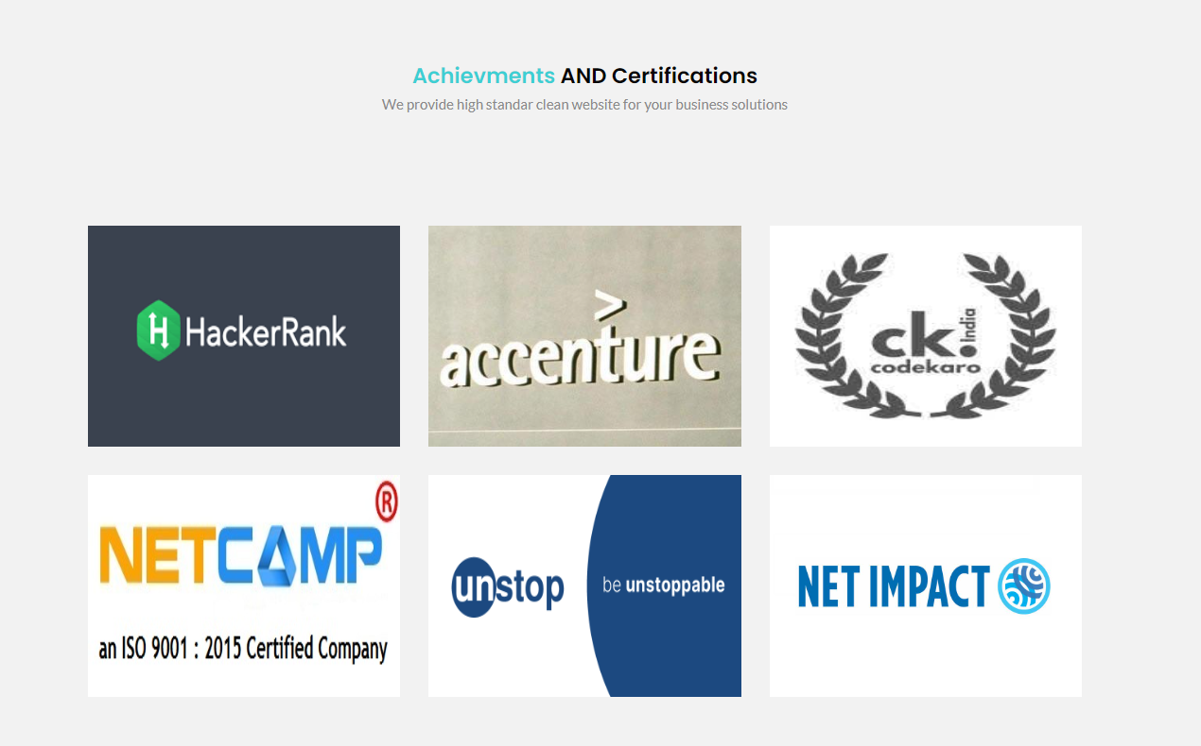

**Projects and Experience Sections**

Here I have mentioned some of my Projects and Internship Experinece's.

*(Project Sections)*

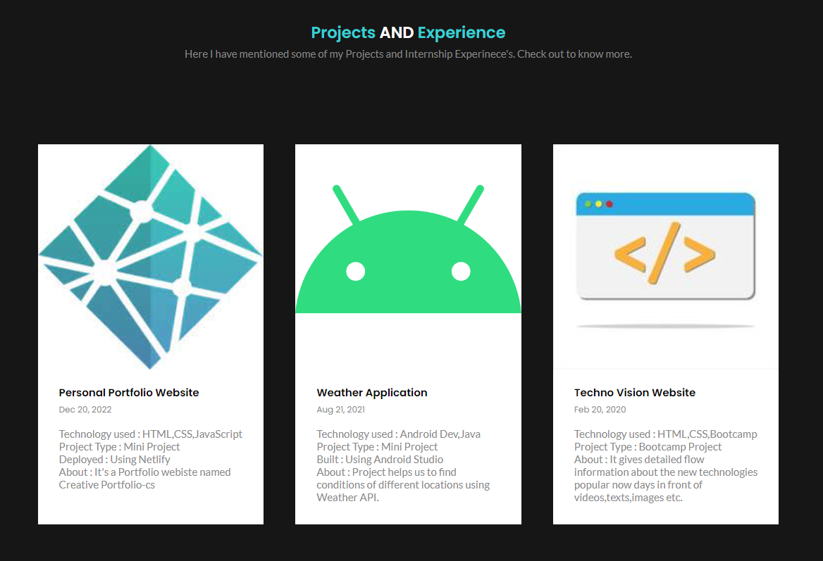

**Contact Section**

Contact Section Consist of Three different parts:

1. 1.Call me
2. 2.Email me At
3. 3.Visit me At

And it also consists of HTML form section in this Conatct Sections having :

1. Name
2. Email
3. Subject
4. text message.

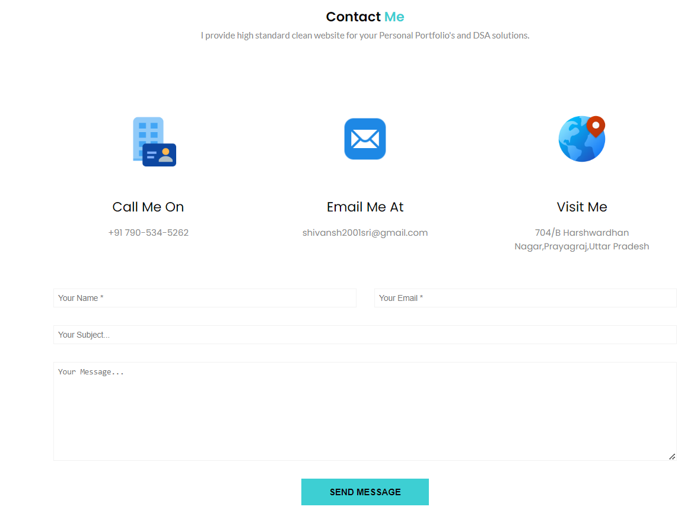

**Footer section**

It consists of black background And creative portfolio logo and social media handle links as mail, Facebook, LinkdIn, Instagram and link Tree and copyright.

*(Footer Section)*



**DEPLOYMENT AND HOSTING**

I Have deployed and hosted this Creative Portfolio website using Netlify application.

Netlify is the platform developers love for building highly-performant and dynamic websites, e-commerce stores and web applications. By uniting an extensive ecosystem of technologies, services and APIs into one workflow, Netlify unlocks new levels of team productivity, while saving time and money.

One of the great advantages of deploying your Gatsby website through Netlify is free hosting and provides secure connections via using *https:connections*.

Below mentioned are details of deployed project:

**Site name :** creativeportfoliocs

**Site Url :** <https://creativeportfoliocs.netlify.app/>

**Owner Name :** Shivansh Srivastava

**Published On :** 19 DECEMBER ,2022

**Deployment Mode :** Manual deploy

**CONCLUSION**

This website is built using HTML, CSS & JavaScript as a front-end Creative Portfolio Website, And deployed using Netlify app in manual mode.

I am quite satisfied with the outcome that I ended up with. I plan to focus on improving the overall performance and remaining elements of the original Creative Portfolio project and its hosted as creativeportfoliocs.netlify.app using Netlify for Free and Published on 19 Dec,2022.

**REFERENCES**

<https://www.freecodecamp.org/>

<https://www.netlify.com/>

<https://code.visualstudio.com/>

<https://stackoverflow.com/>

<https://www.w3schools.com/>